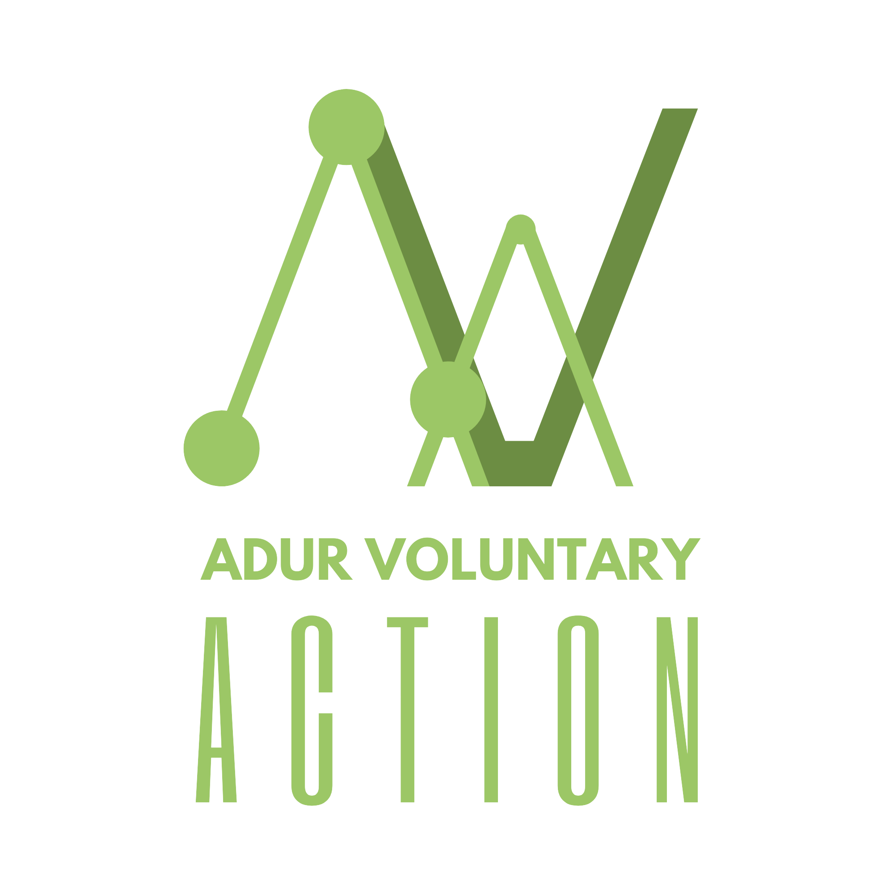

Role Title: Treasurer Trustee

Direct Report: Works closely with the board of trustees and book-keeper

Background: Finance & good governance

1.0 Role Summary

- Working with our book-keeper to monitor the financial standing of the charity and report to the Board and CEO regarding risk, forecasting, income streams, out-going expenses and the financial soundness of the charity
- Ensure that annual accounts are submitted to all relevant regulators in a timely fashion.
- Liaising with external auditors on financial issues and ensuring that the organsiation’s finances are responsibly managed/invested for the betterment of the organisation’s work and for the beneficiaries it serves.
- Responsibilities
- Ensure all strategic plans are financially appraised and budgets are aligned to both short-term and long-term objectives each year.
- Oversee planning/budgeting processes in participation with the Board and constructively challenge where required.
- Suggest alternative scenarios while evaluating strategic plans as a part of the risk management process and as a part of performance and reporting scenarios.
- Create greater transparency and accountability to improve resource allocation and charity’s image by adding specific measures as per SORP guidelines.
- Board level liaison with external auditors on specific issues in the auditing process and related board representations.
- Guide and advise fellow trustees to formally approve the annual report and audited accounts.
- Explain technicalities of accounts in plain language which is fully understood by the trustees.
- Lead the Board’s duty to ensure proper accounting records are kept, financial resources are controlled, invested and economically spent in line with governance, legal and regulatory requirements

3.0 Person Specification
- Familiarity of working in financial background (i.e. book-keeper)
- Knowledge of charity SORP and impending changes.
- Competent use of IT skills.
- Proven ability to communicate and explain financial information to members of the Board and other stakeholders.
- Analytical and evaluation skills, demonstrating good judgement.
- Understanding and acceptance of the legal duties, responsibilities and liabilities of trusteeship.
- Good communication and leadership skills

4.0 Time Commitment
- The Board meets 12 times a year and the Treasurer is asked to be available as much as possible for these = 1.5 hrs
- Seeking finance information from the book-keeper to support grant applications and reporting back on grant spend and outputs = 1.5 hrs
- Therefore, 3hrs a month

5.0 Location
- Working from home, Board meetings are held at the organisation’s premises:
Co-op Community Space, Ham Road, Shoreham. BN43 6PA or online via Zoom or Team

